**WEEK 1 REPORT**

Domain: Applied Data Science

**Project:**  Smart Lender- Applicant Credibility for Loan Approval

**Phase 1 Description: Preparation Phase (Prerequisites, Registrations, Environment Set-up, etc.)**

**1.1 Accessed the resources (courses) in project dashboard**

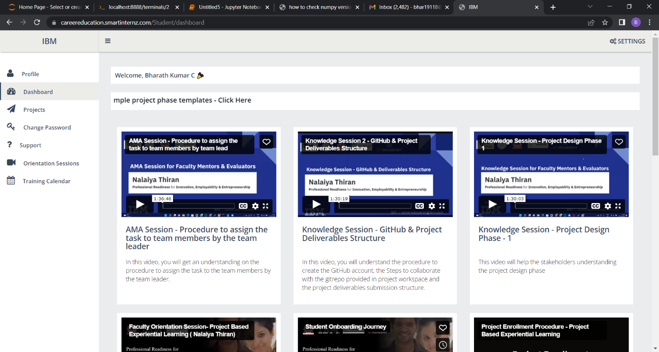

**1.2 Joined the mentoring channel via platform & rocket-chat mobile app**

**1.3 Accessed the guided project workspace**

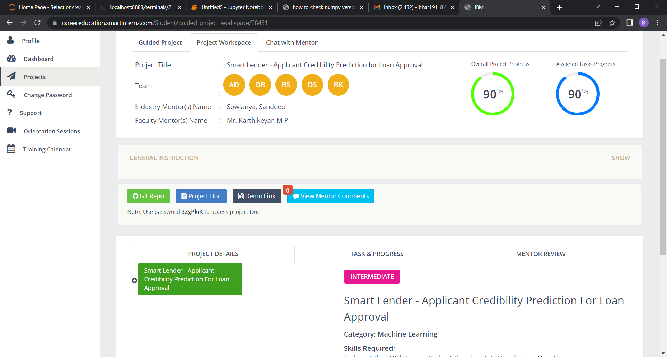

**1.4 Registered on IBM Academic Initiative & Apply Feature code for IBM Cloud Credits**

**1.5 Created GitHub account & collaborate with Project Repository in project workspace**

